The Black Scholes

The Black-Scholes Model, conceived by economists Fischer Black and Myron Scholes in collaboration with Robert Merton, serves as a widely employed mathematical framework for the valuation of financial options, with a particular focus on call options. This model offers a theoretical approximation of the equitable market price for European-style options, contingent upon the satisfaction of specific assumptions. In essence, the Black-Scholes Model provides a structured approach to estimating the value of call options in financial markets.

* 1. The Equation Itself:

$$\frac{∂F}{∂t}+\frac{1}{2}σ^{2}s^{2}\frac{∂^{2}t}{∂s^{2}}+rs\frac{∂F}{∂s}-rF=0$$

Here-

F = Price of Options

$σ$ = Implied Volatility

S = Spot Price

r = Risk Free Rate

* 1. Solutions (Analytical):

This equation has an infinite number of solutions. Therefore, to obtain a unique solution, hence avoiding the possibilities of arbitrage, boundary conditions must be imposed. We note that the highest derivative with respect to S is a second order derivative and the highest derivative with respect to t is a first order derivative. Hence, we impose two conditions about the behaviour of the solution in S and one in t.

* Let us now introduce the boundary conditions for a **European Call Option** whose payoff at time of delivery or expiry is denoted as:
$$P\left(S,T\right)=\max\left(S-K,0\right)$$

* Now for all the time we know if the price of asset is zero, then the payoff will be denoted as:
$$P\left(0,t\right)=0$$

* Also, we know that as price of asset starts increasing the payoff will be:

$P\left(S,t\right)→S-K$ as $S→∞$

the following assumptions were made during this calculation:

* The risk-free interest rate r, and asset volatility are constant
* The underlying asset prices follow a lognormal random walk
* There are no arbitrage opportunities hence all portfolios would earn equal returns.
* During delta hedging of a portfolio, no transaction costs are incurred.
* The short selling of securities is allowed and the assets are divisible.
* No dividends are paid during the entire period of the contract.
* There is continuous trading of the underlying assets.

The final analytical formula that comes up is:

Where:

* 1. Solutions (Numerical):

Here we are going to use the numerical methods to find solutions to the equation and compare them with the analytical ones:

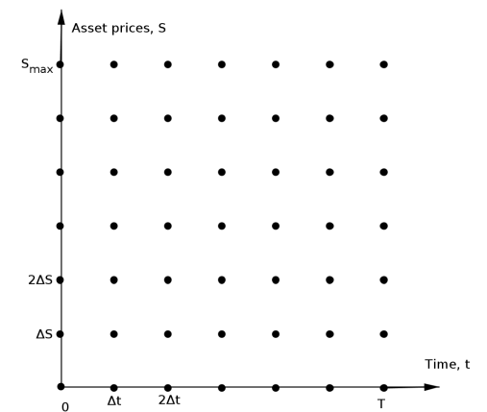

The S, t plane

Equation Discretization:

we suppose that the option will mature after time T. We then divide this time into N equally spaced intervals each of length ∆t. Thus, we have N +1 points. Similarly, we need to discretize the stock price. Assume that the highest price of the stock is Smax, dividing Smax into M equally spaced intervals of length ∆S, we have M +1 points.

$$0,Δt,2Δt,…,NΔt,$$

Where $Δt=\frac{T}{N}$

$$0,Δδ,2ΔS,…,MΔS$$

Where $ΔS=\frac{S_{max}}{M}$

Therefore the option price for time tn with the asset price Sm is Fn,m and its value is :

$$F_{n,m}=F\left(mΔs,nΔt\right)=F\left(Sm,t_{n}\right)$$

In the context of the Black-Scholes partial differential equation (PDE) for a call option, it is necessary to substitute the partial derivatives with approximations derived from Taylor series expansions around critical points. This entails obtaining finite difference approximations for the first-order partial derivatives with respect to time (t) and underlying asset price (S), as well as the second-order partial derivative with respect to S. Through careful consideration of the Taylor series expansions, we derive the pertinent finite difference approximations.

Using appropriate assumption and Taylor series we get:

$$Ft\left(t,S\right)=\frac{F\left(t,S\right)-F\left(t-∆t,S\right)}{∆t}+O\left(∆t\right),$$

$$Ft(t,S) ≈\frac{ Fn,m -Fn-1,m}{∆t}$$

Integrating these approximations into the Black-Scholes partial differential equation (PDE) results in a discrete difference equation. This difference equation becomes instrumental in deriving the approximation for the value of the call option, denoted as F (t, S).

Boundary Conditions:

To ensure the uniqueness of the price for a European call option, characterized by the payoff max (ST- K, 0), it becomes imperative to impose specific boundary and initial conditions on the equation.

$$F=max⁡(m∆S-K , 0) for m = 0,1,2,···,M$$

The initial condition provides the option value i.e. F at the maturity time T, not at the inception of the option. Consequently, it is necessary to discount this value back to the initial time zero. For an initial price S0, the option price at time t = 0 is expressed as F0,M/2 for even steps M and F0,(M+1)/2 for odd steps M, where the assumption is made that Smax = 2S0. This adjustment ensures the proper valuation of the option at its starting point, accounting for the discounting factor.

$F(t,S+∆S) = F(t,S) + F_{S}(t,S)∆S + \frac{1}{2}F_{SS}(t,S){(∆S)}^{2} + O({(∆S)}^{3})$,

$$F\left(t,S\right)=\frac{F\left(t,S+∆S\right)-F\left(t,S\right)}{∆S}+O\left(∆S\right),$$

$$≈\frac{F_{n,m+1 -}F_{n,m}}{∆S}$$

Above eq. is forward difference approximation.

Now, the expansion of $F(t,S-∆S)$ is given by:

$$F_{s}(t,S) = F(t,S) - F(t,S)∆S + \frac{1}{2}F_{SS}(t,S){(∆S)}^{2} - O({∆S}^{3}),$$

This implies that first partial derivative is

$$F_{s}\left(t,S\right)=\frac{F\left(t,S\right)-F\left(t,S-ΔS\right)}{ΔS}+O\left(ΔS\right),$$

$$≈\frac{F_{n,m+1}-F_{n,m-1}}{ΔS}.$$

This results to backward difference form of approximation.

$$F_{s}\left(t,S\right)=\frac{F\left(t,S+ΔS\right)-F\left(t,S-ΔS\right)}{ΔS}+{O(\left(ΔS\right))}^{2},$$

$$≈\frac{F_{n,m}-F_{n,m-1}}{2ΔS}.$$

The approximation of the second order partial derivative of the stock price is:

$$F_{s}\left(t,S\right)=\frac{F\left(t,S+ΔS\right) - 2F\left(t,S\right)+F\left(t,S-ΔS\right) }{ΔS}+{O(\left(ΔS\right))}^{2},$$

$$≈\frac{{F_{n,m+1} - 2F}_{n,m}+F_{n,m-1}}{{(ΔS)}^{2}}.$$

Required approximation for the time derivative:

$$F\left(t+Δt,S\right)=F\left(t,S\right)+ΔtF_{t}\left(t,5\right)+{\left(Δt\right)}^{2}F_{tt}\left(t,S\right)+O\left({\left(Δt\right)}^{3}\right).$$

So, the forward difference derivative is:

$$F_{t}\left(t,S\right)=\frac{F\left(t+Δt,S\right) - F\left(t,S\right) }{∆t} +O\left(∆t\right),$$

$$≈\frac{{F_{n+1,m} - F}_{n,m} }{∆t}.$$

Similarly, backward difference in time looks like

$$F_{t}\left(t,S\right)=\frac{F\left(t,S\right) - F\left(t+Δt,S\right) }{∆t} +O\left(∆t\right),$$

$$≈\frac{{F_{n,m} - F}_{n-1,m} }{∆t}.$$

Explicit Method:

The explicit method is obtained by taking the backward difference approximation in time, here we have $S=mΔS$.

$$\frac{F_{n,m}-F_{Π-1,n}}{Δt}+rmΔs\frac{F_{n,m+1}-F_{n,m-1}}{2ΔS} + \frac{1}{2}σ^{2}m^{2}{\left(ΔS\right)}^{2}\frac{F_{n,1^{m}+1}-2F_{n,m}+F_{n,m-1}}{{\left(ΔS\right)}^{2}}-rF_{n,m}=0.$$

Rewriting the above equation so that the present value of the underlying asset depends on the future values. And we have, $$F_{n,m}=\frac{1}{1+rΔt}(aF_{n+1,m-1}+bF_{n+1,m}+cF_{n+1,m+1}).$$

$$where the coefficients are :$$

$$a=\frac{Δt}{2}\left(σ^{2}m^{2}-rm\right), \\ b=1-Δt\left(σ^{2}m^{2}\right), \\ c=\frac{Δt}{2}\left(rm+σ^{2}m^{2}\right)⋅$$

for n = N −1, N −2, ···,1,0 and m = 1,2, ···M −1.

The explicit method leads to above equation which gives a relationship between one value of the option at time $nΔt$ ($i.e., F_{n,m}$)and three different values of the option at time ($n+1)Δt$ (i.e., $F_{n+1,m-1},F_{n+1,m},F_{n+1,m+1}$).For solving this equation we have used the two boundary conditions which therefore gives the values of F(n+1,m+1) and thus makes it easy to solve. Using this method, we have solved for each value of m and n.

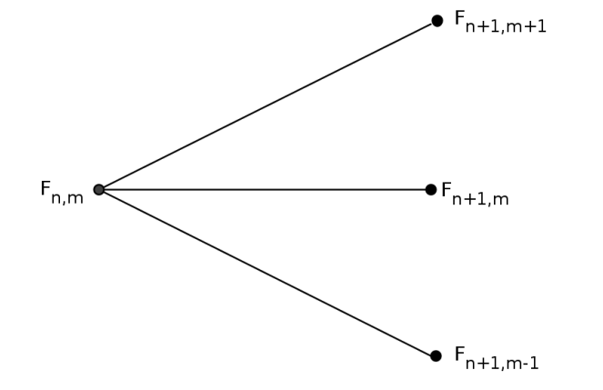

Explicit Finite Difference.

Implicit Method:

It is obtained by replacing the time derivative with the forward difference approximation. We discretize both the time and the underlying asset price domains in order to apply the implicit finite difference method to the Black-Scholes equation.

$$\frac{F_{n+1,m}-F_{n,n}}{Δt}+rmΔs\frac{F_{n,m+1}-F_{n,m-1}}{2ΔS} + \frac{1}{2}σ^{2}m^{2}{\left(ΔS\right)}^{2}\frac{F_{n,m+1}-2F_{n,m}+F_{n,m-1}}{{\left(ΔS\right)}^{2}}-rF_{n,m}=0.$$

This can be represented by:

$$F_{n+1,m}=aF_{n,m-1}+bF_{n,m}+cF_{n,m+1}.$$

Where,

$$a=\frac{Δt}{2}\left({rm - σ}^{2}m^{2}\right), \\ b=1+Δt\left(σ^{2}m^{2}+r\right), \\ c=-\frac{Δt}{2}\left(rm+σ^{2}m^{2}\right)⋅$$

for n = N −1, N −2, ···,1,0 and m = 1,2, ···M −1.

Therefore, the implicit finite difference method provides a stable and accurate numerical approximation for solving the Black-Scholes equation and estimating option values by formulating them as a system of linear equations and solving it iteratively until convergence.

Here we solve this method by using Matrix multiplication. We use the AX=B method to find matrix X as follows:

A= [ [C(19),B(19),A(19),0,0,0,0,…… 0], X=[[F(n,20)] B=[[F(n+1,20)] [0,C(18),B (18),A(18),0,0,0,…….0], [F(n,19)]….. [F(n+1,19)]…..

………. ……

[0,………………0,C(1),B(1),A(1)]] [F(n,0)] [F(n+1,0)]

A is a 19X21 matrix and X is 21X1 so we can’t inverse it that is the main issue for this method, to resolve this we solve MX+R=B instead as follows:

M= [ [B(19),A(19),0,0,0,0,…… 0], X=[[F(n,19)] B=[[F(n+1,19)] [C(18),B (18),A(18),0,0,0,…….0], [F(n,18)]….. [F(n+1,18)]…..

………. ………. ………..

[0,………………0,C(1),B(1)]] [F(n,1)] [F(n+1,1)]

R=[[F(n+1,20)xC(19)]

[0],[0],……

[F(n+1,0)xA(1)]]

As one can see now matrix M is 19x19 invertible and it is much more easy to find solution for this method.

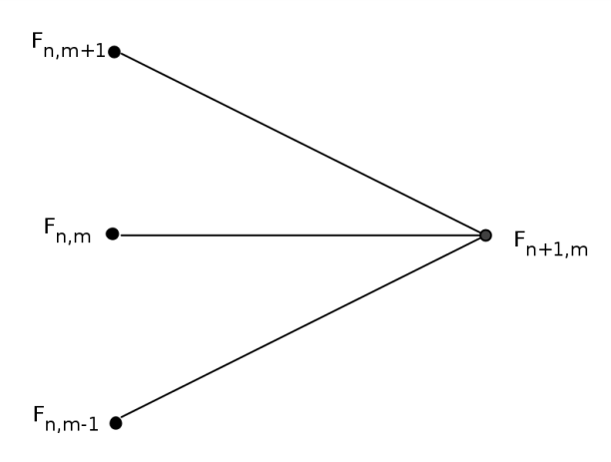

Implicit Finite Difference.

* 1. Comparing Solutions (Analytical and Numerical):

This part is done in the excel file.